**B_18_DAYAL ADITYA KISHOR**

**Assignment No. 1**

**Title:**

Implementation of DDL commands of SQL with suitable examples

* Create table
* Alter table
* Drop Table

**Problem Statement:**

1. Create tables with ORACLE using SQL DDL statements  
   Sailor(sid:integer, sname:string, rating:integer, age:real)  
   Boat(bid:integer, bname:string, color:integer)  
   where sid and bid is primary key
2. Add column (bdate:string) in Sailor table
3. Modify the type of color column in Boat to string
4. Delete column bdate from Sailor table
5. Change the name of the column color to Boat_color in Boat table
6. Rename table Boat to Ship
7. Drop the Ship

**Answer:**

1.Create Tables Sailor and Boat

create table Sailor (sid int primary key, sname varchar(20), rating int, age real);

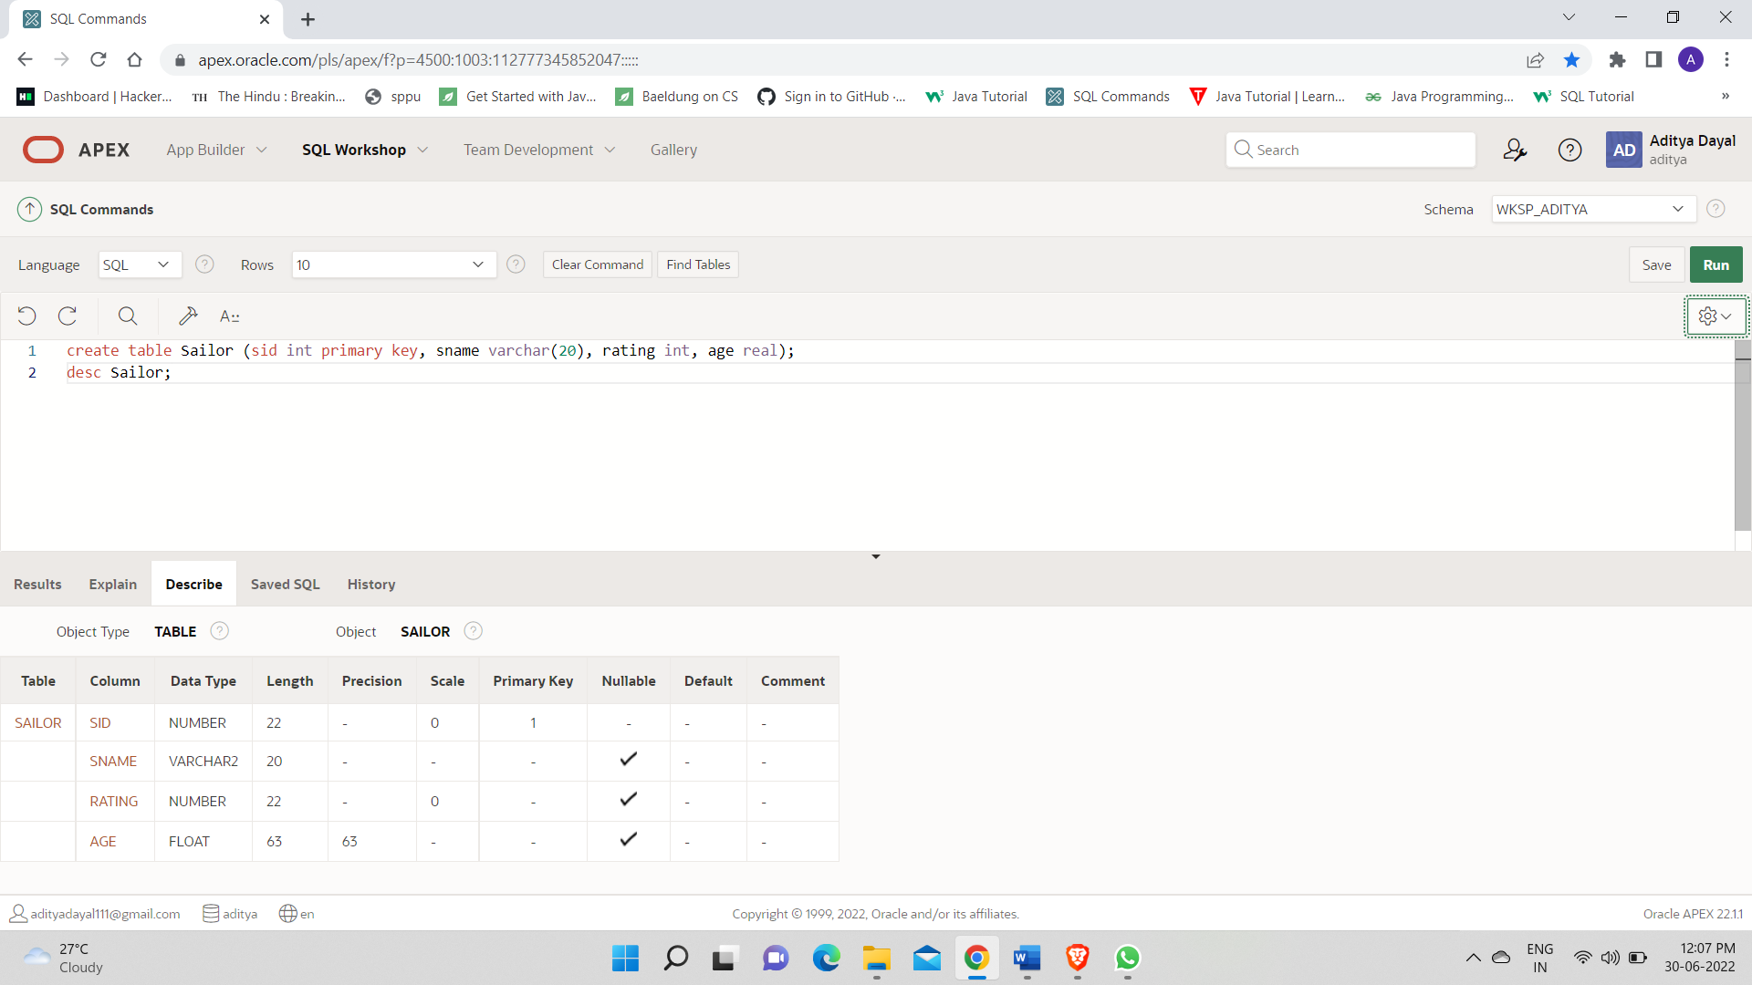

Create Table Boat(Bid int primary key, Bname varchar(20),color int );

desc Boat;

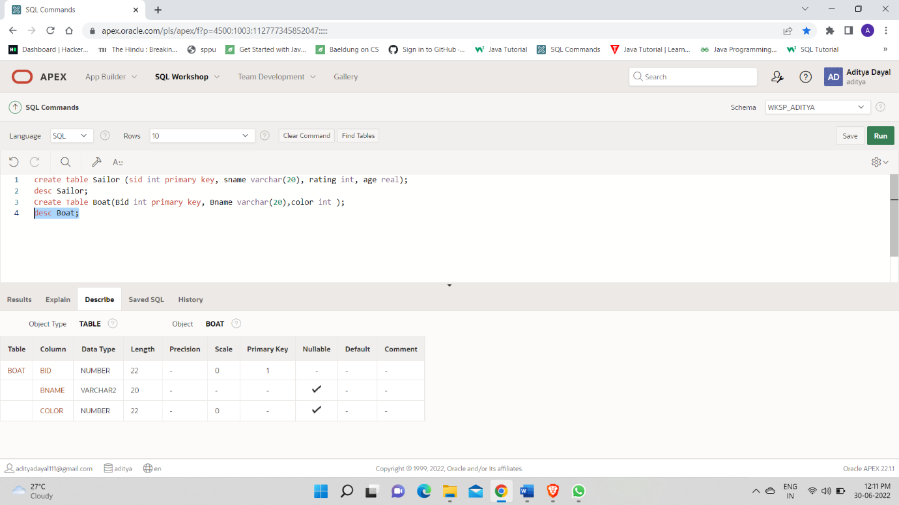

2.

Alter table Sailor add Bdate varchar(20);

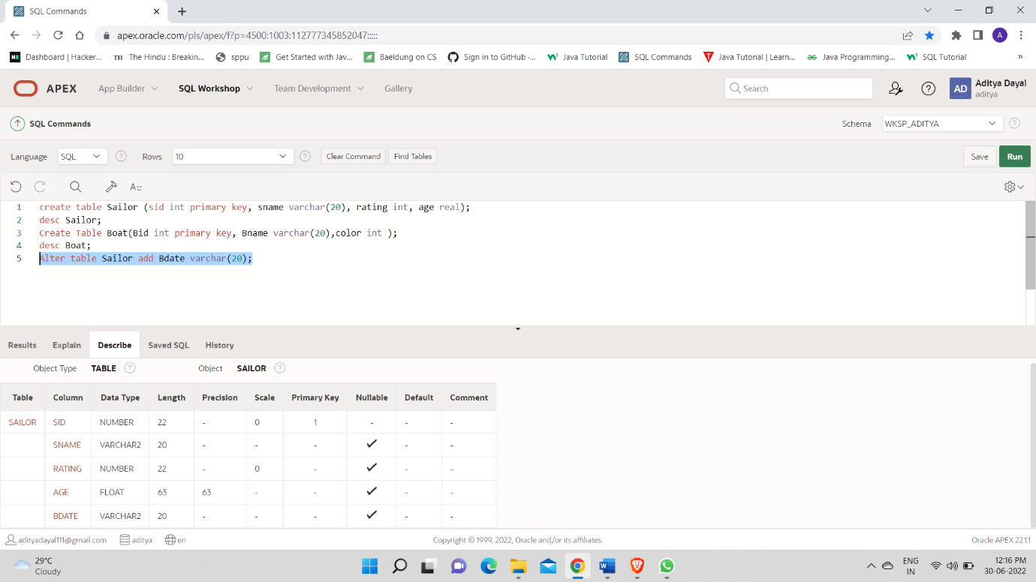

3.

Alter table Boat modify color varchar(20);

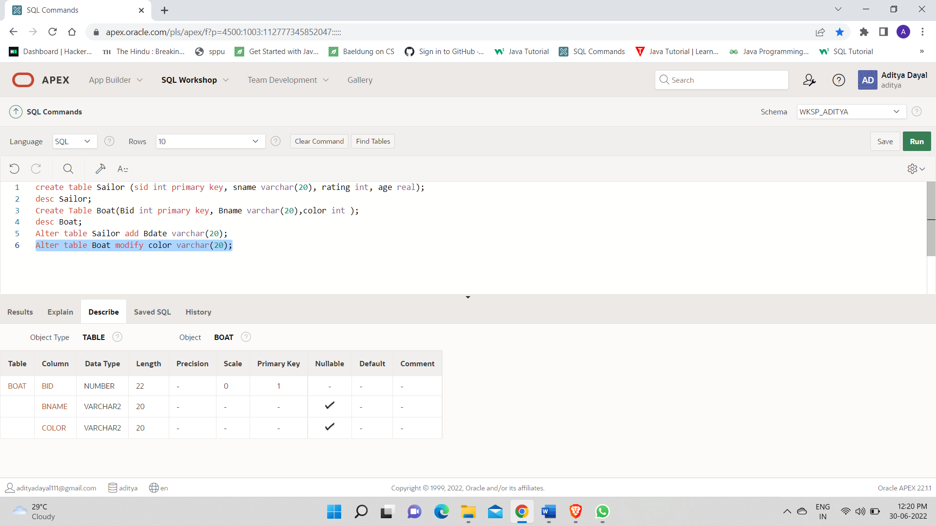

4.

alter table Sailor drop column bdate;

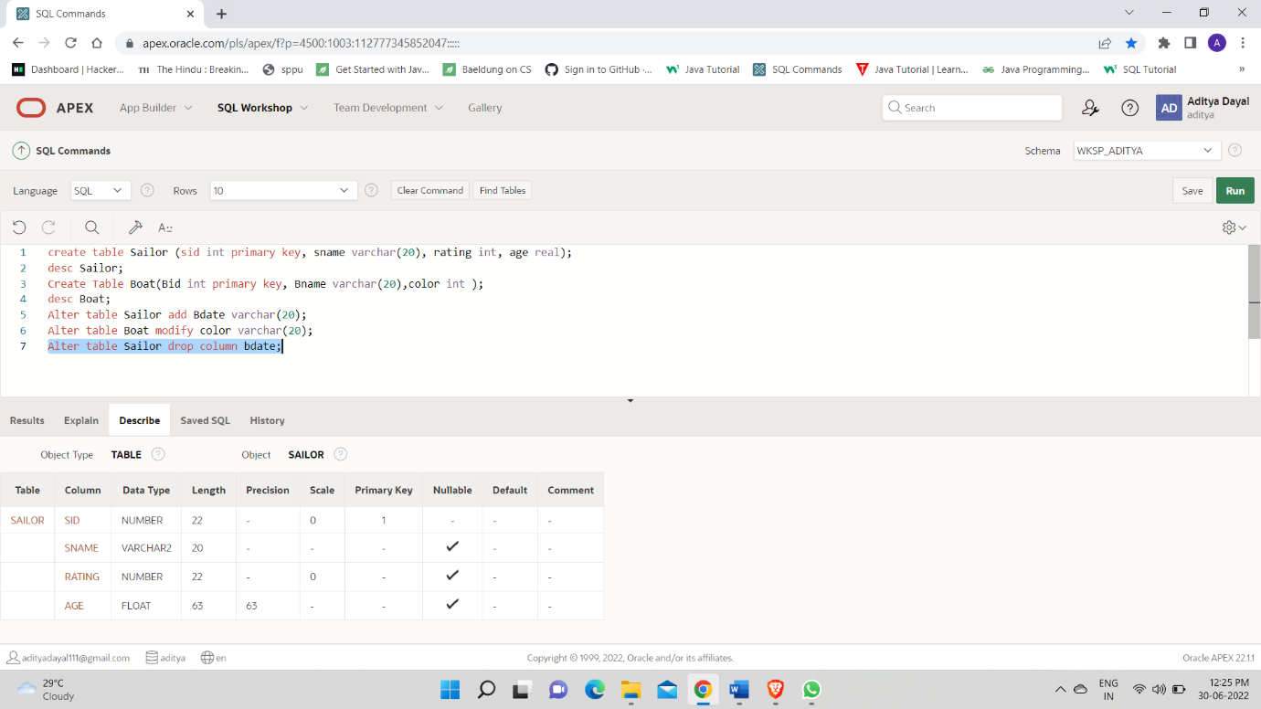

5.

alter table Boat rename column color to Boat_color;

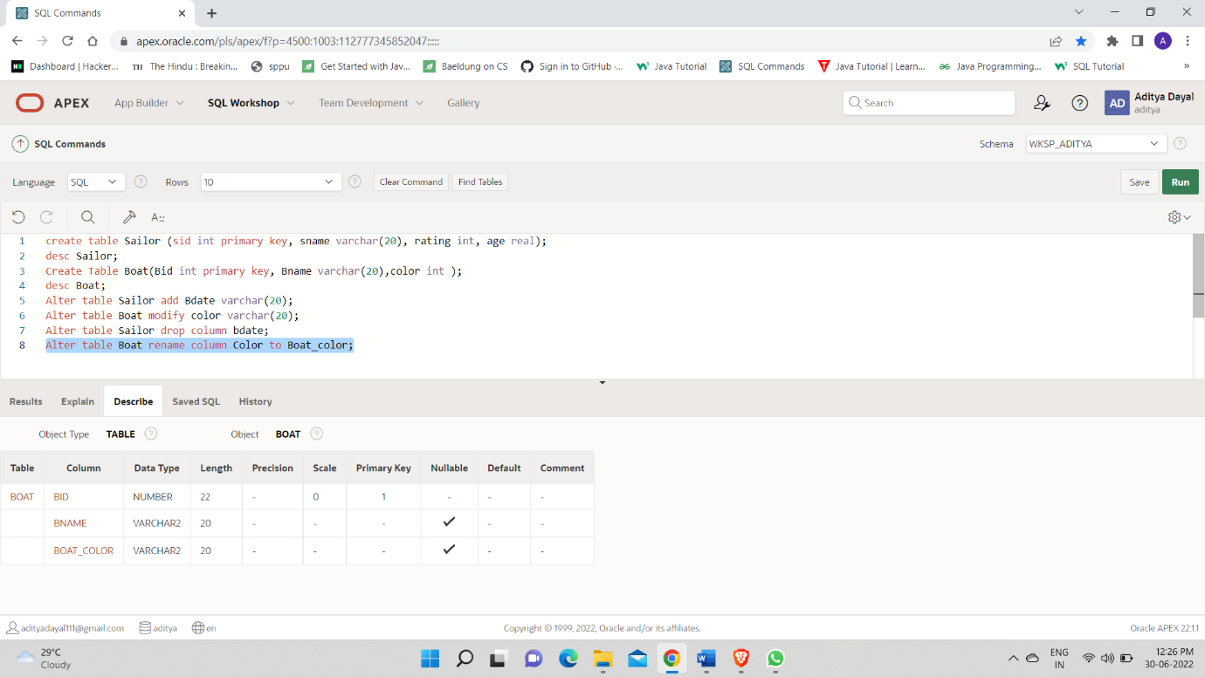

6.

alter table Boat rename to Ship;

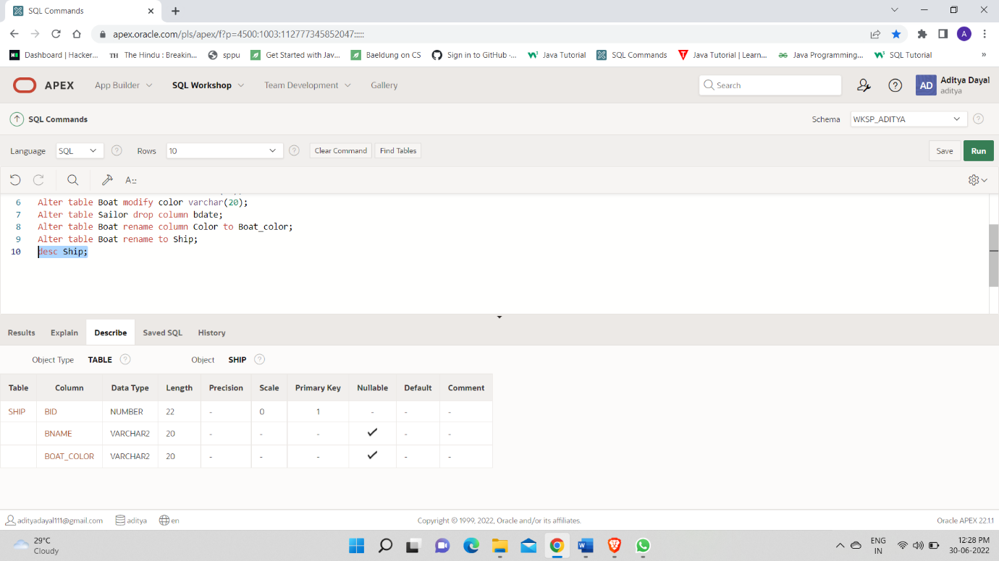

7.

drop table Ship;

